**Name: Asma Sharif**

**Semester: 6th BSCS**

**Roll No: 41814**

**Computer Networks**

Task1: Connect 4 PCs with the HUB in cisco packet tracer and send data from PC 1 to PC 2 and check the working of HUB through simulation mode. (05 Marks)

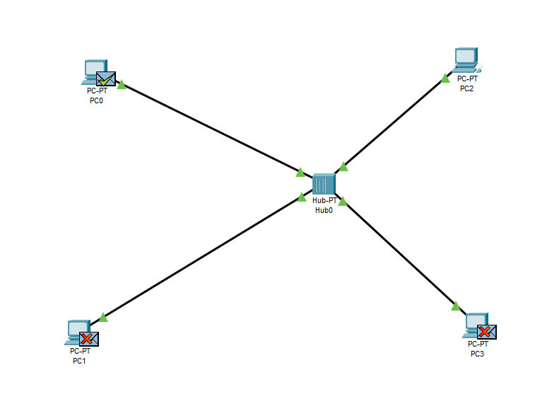

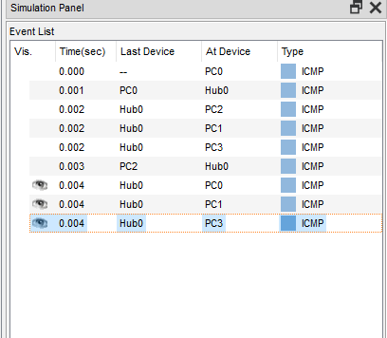

Task 2: Connect 4 PCs with the SWITCH in cisco packet tracer and send data from PC 1 to PC 2 and check the working of SWITCH through simulation mode. (05 Marks)

